SUPPORT VECTOR MACHINES
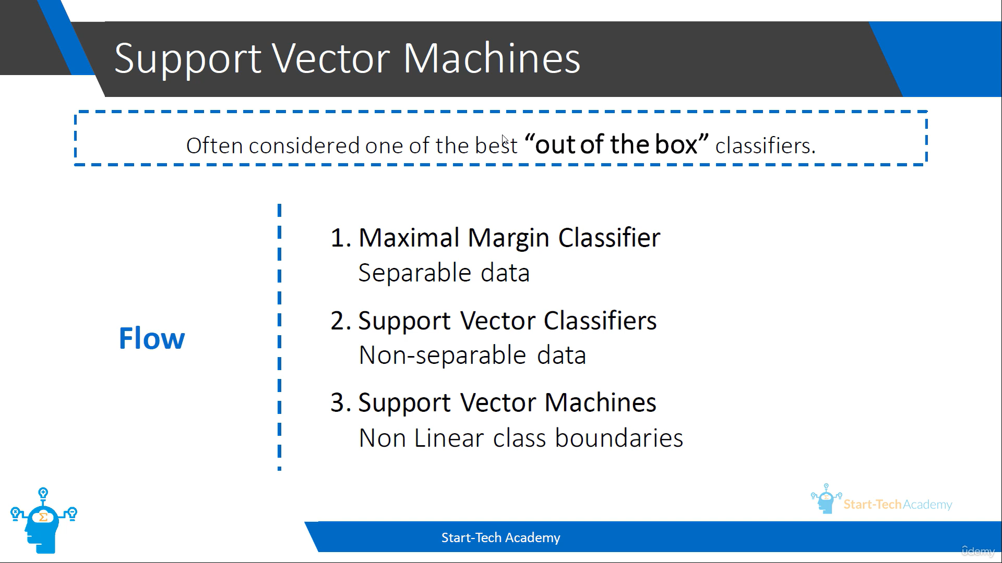
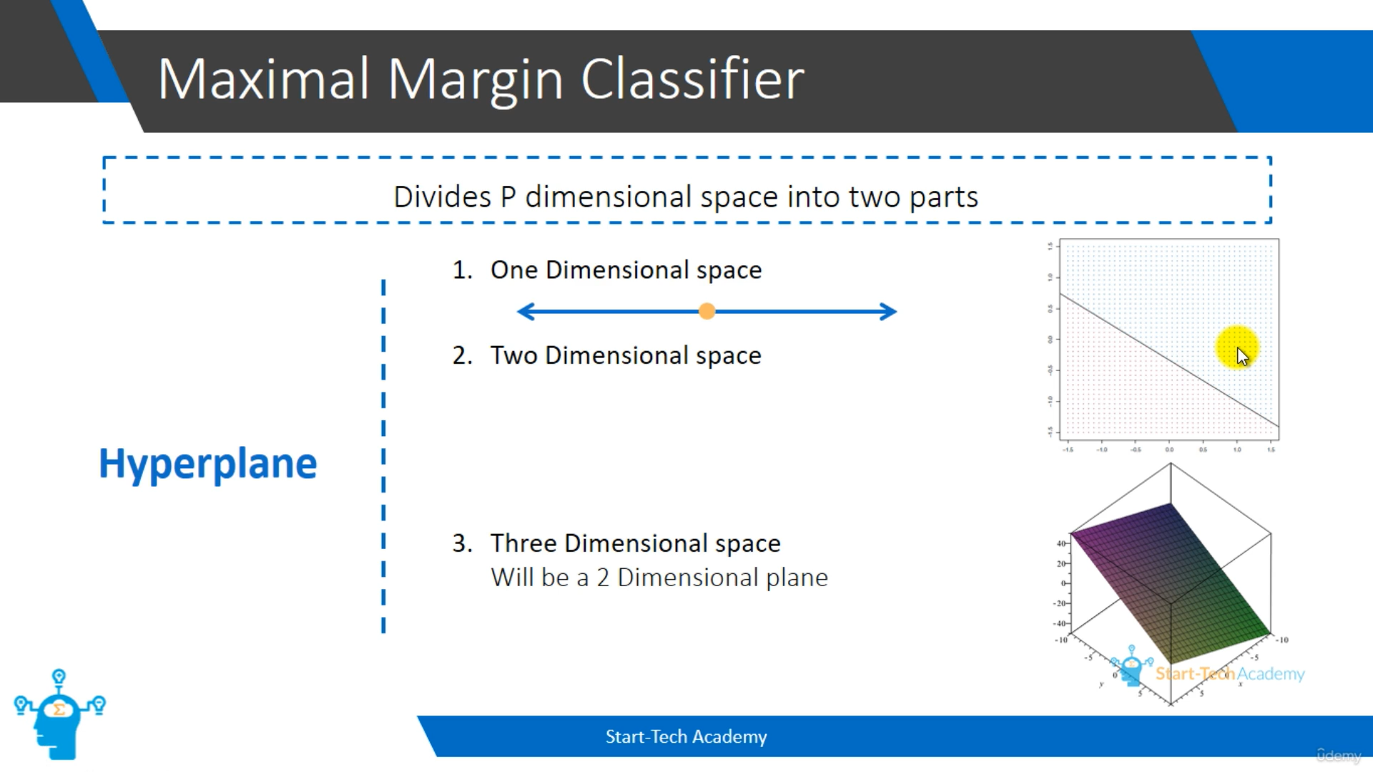
Divides ‘p’ dimensional space into two parts. For example, if we have 2 dimensional space, it will divide into two parts by using a one dimensional line. Likewise, if we have a 3 dimensional space, it will divide into two parts by using a 2 dimensional plane.
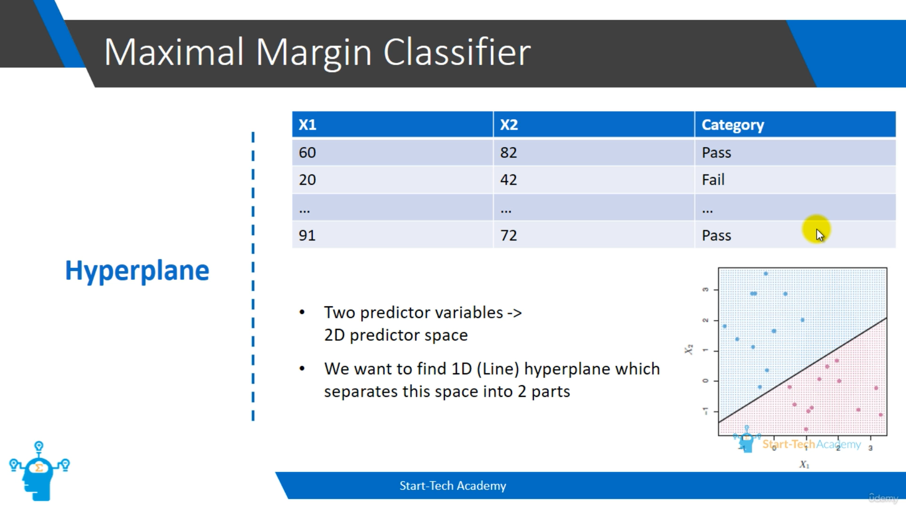
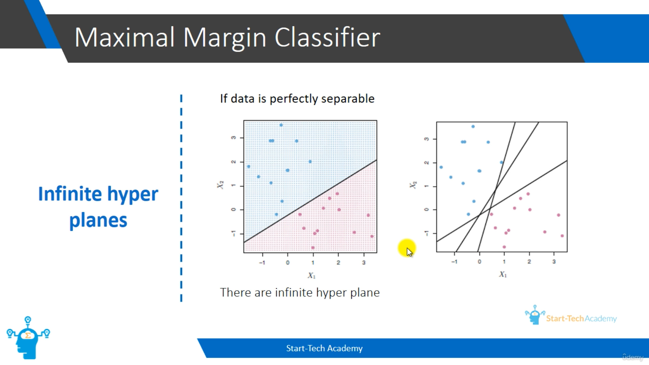
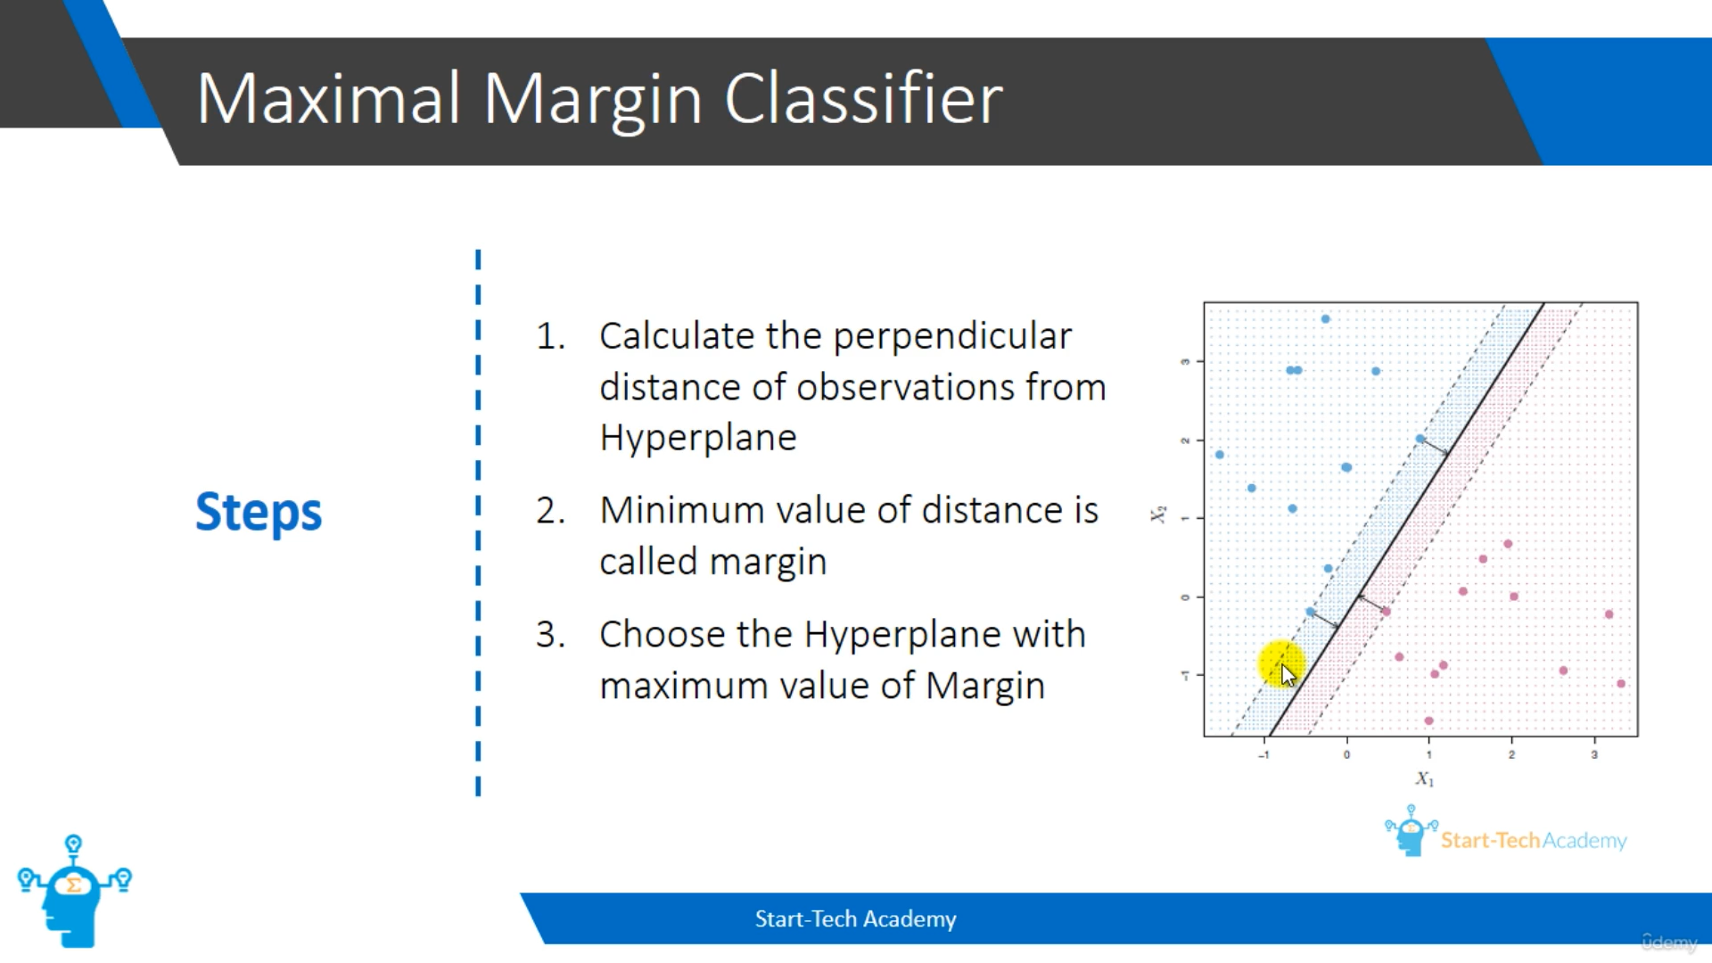
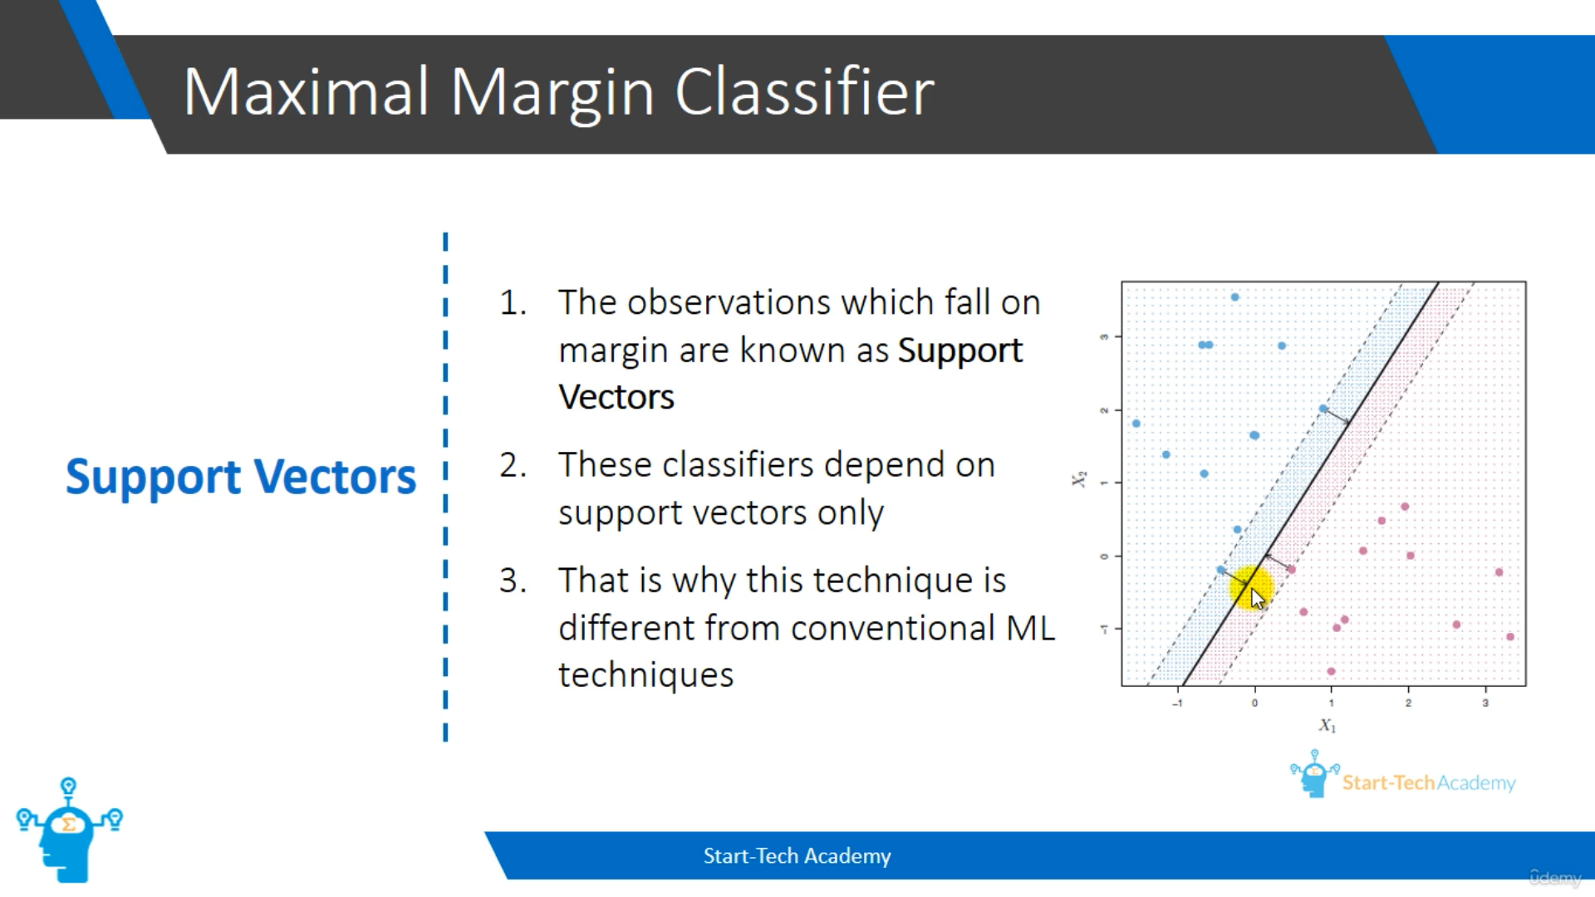
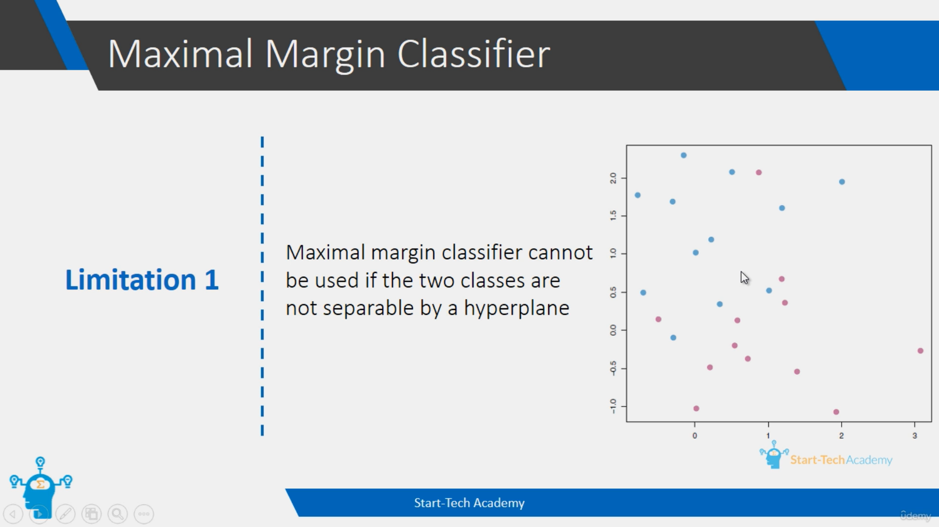
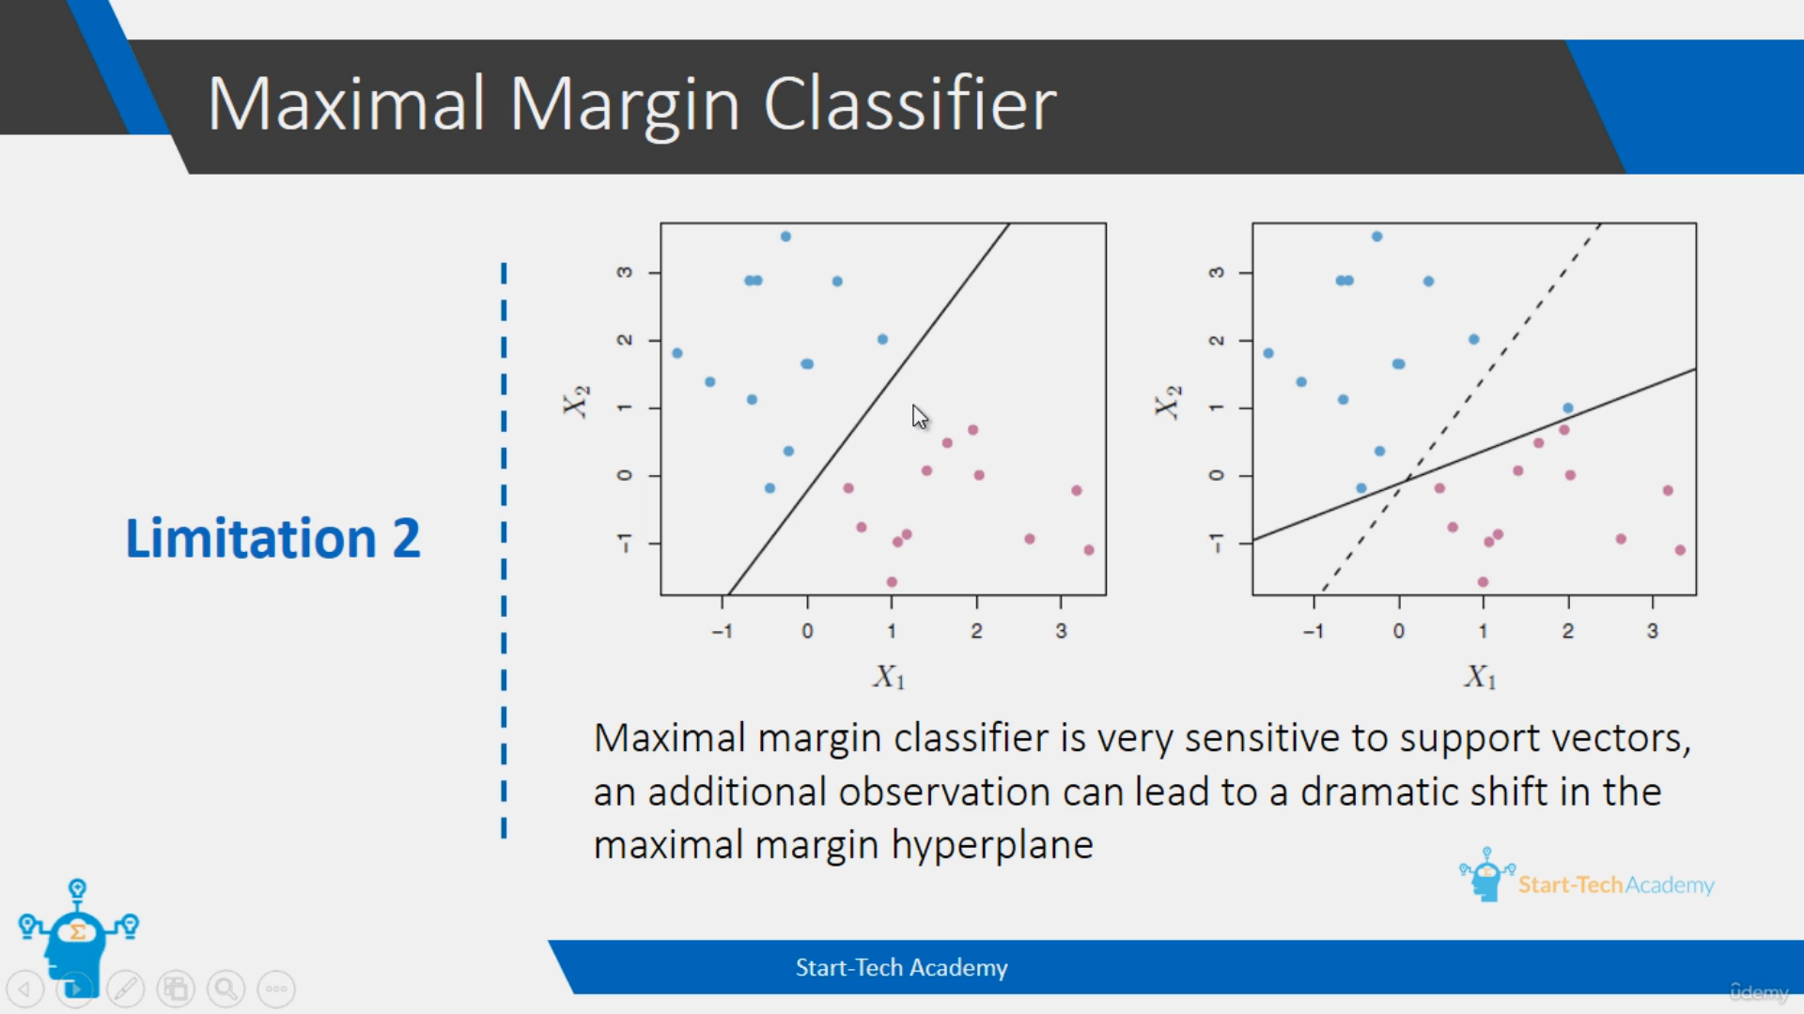
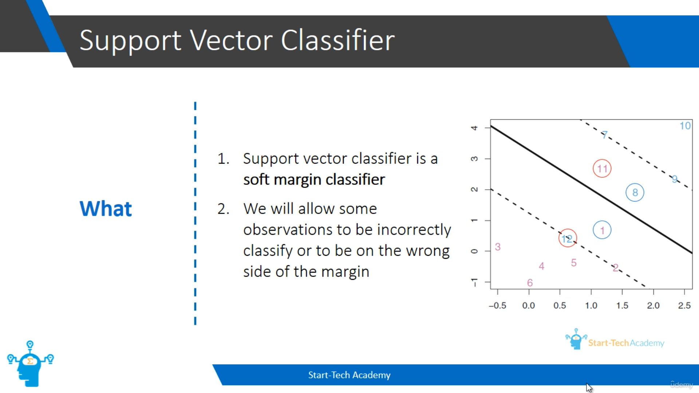
We can allow two types of error. One is rightly classified but on the wrong side of the margin. Eg: Points 1 and 8. Another one is wrongly classified by the hyperplane itself. Eg: Points 12 and 11.
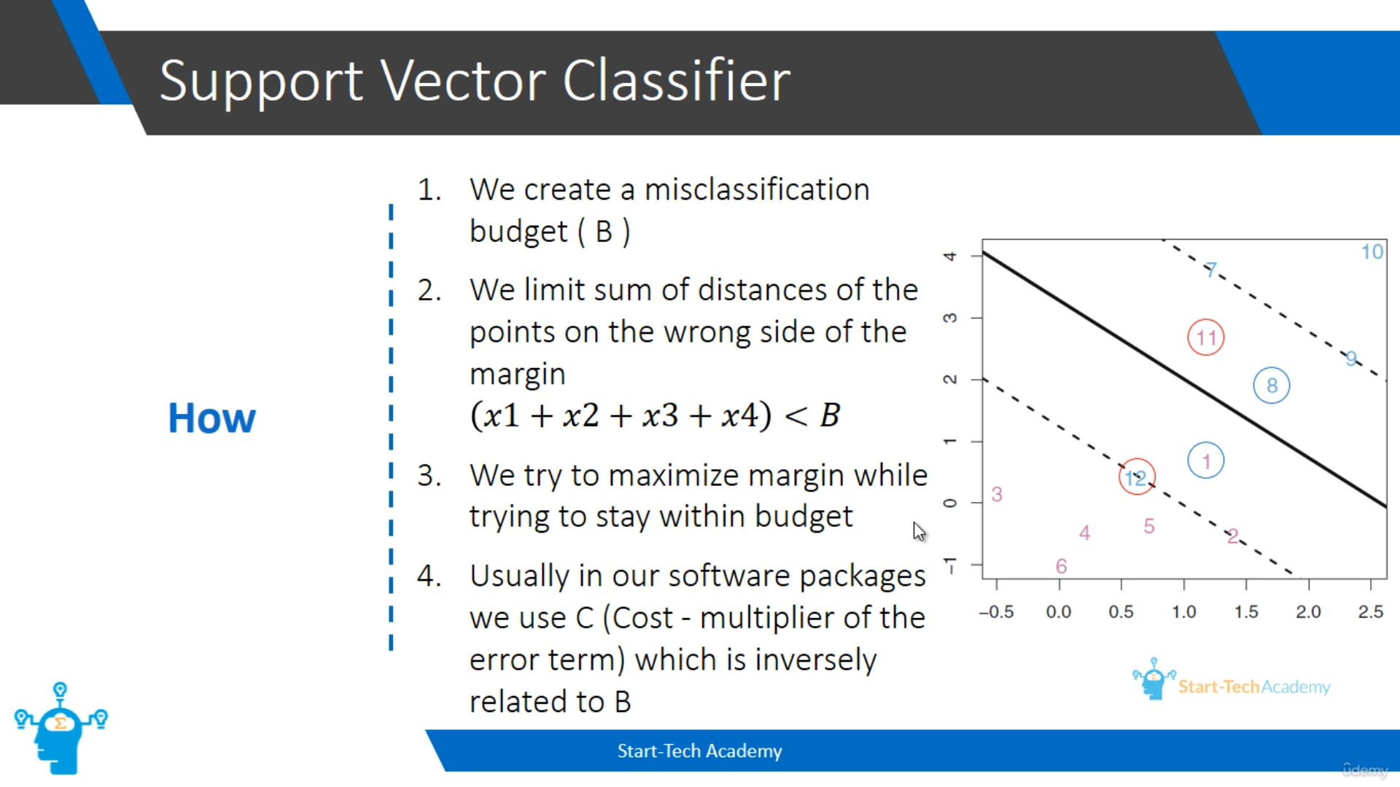
Here the error points distance from hyperplane are calculated as x1, x2, x3 and x4. For eg: x1 = distance of point 1 from hyperplane and x2 = distance of point 11 from hyperplane. The addition of all error points distance need to be less than B(misclassification budget).
